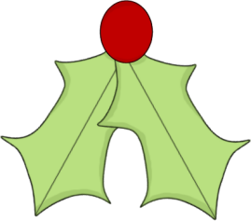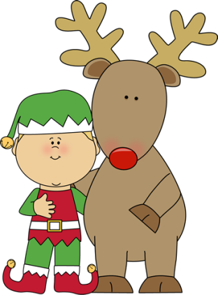

Class Information

**Important Dates**

***December 7***: School Organizational Team   
Elections, 7:00 am – 4:30 pm  
***December 7***: Winter Assembly, 1:30 pm  
Parents Invited  
***December 14***: Parent-Teacher Conferences  
***No School*** for students  
***December 16 – January 2***: Winter Break  
***No School***  
***December 30***: Ella’s Birthday  
***January 3, 2017***: Classes Resume

**Second Grade**

**Ms. Crouse   
alcrouse@interact.ccsd.net**

**Mrs. Leverence  
aaleverence@interact.ccsd.net**

Dec. 5-8, 2016

**IMPORTANT:** This Wednesday, the students have an assembly in the afternoon. All students in grades K-12 are asked to wear holiday colors (red, green, white) and black/dark pants, if possible.

The outdoor water fountains at school have been turned off due to cold weather for the winter. Please send a water bottle with your child to allow water consumption throughout the day. If they would like to keep it at school, we can fill it in the multi-purpose room in the mornings and at lunchtime.

Also due to cold weather, a lot of students are getting chapped lips easily. If your child is susceptible to chapped lips or dry skin, they may have chapstick and/or lotion in their backpack. This will save trips to the nurse’s office for those reasons.

Please see the note on the reverse side for information about next Thursday (the last   
 day before Winter Break).

What’s Going on in School

**Reading:** Fluency/comprehension  
**Math:** Addition/Subtraction  
**Writing:** 5-sentence paragraphs  
**Social Studies/Science:** Holidays

***Read 20 minutes each evening.***

