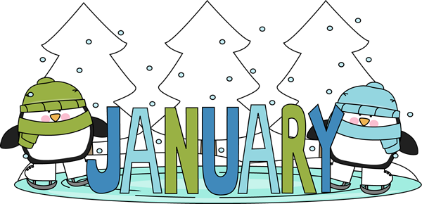

**Reading:** Benchmark Assessments  
**Math:** Subtraction with Regrouping  
**Writing:** Benchmark Assessments  
**Social Studies/Science:** New Year;   
 Martin Luther King, Jr.

***Read 20 minutes each evening.  
Math websites for practice:***<https://www.khanacademy.org/math/arithmetic-home/addition-subtraction/subtract-within-100/e/subtraction_3>

<http://www.softschools.com/math/subtraction/2_digit_subtraction/2_digit_subtraction_with_regrouping/>

**Important Dates**

January 1: Happy New Year!  
January 2: No School  
January 3: Classes Resume  
January 16: Martin Luther King, Jr.  
 Day – No School  
January 19: End of Semester  
January 27: Draco’s Birthday  
January 28: Jayme’s Birthday

**In School…**

Welcome back and Happy New Year! We hope you had a great and restful break.

We are making some changes with the classes in the new year. To better meet the needs of the students in literacy, we are rearranging the schedule to learn and practice our phonics component first thing in the morning. If you drive your child to school, please ensure he/she is here no later than 7:55 as instruction will now begin immediately and he/she will be considered tardy. Breakfast will now follow our phonics lessons and will be at 8:30.

We have a new peanut allergy in our class. Please do not send foods to school containing peanuts for the health and safety of our students.

The first semester ends next Thursday, January 19. Report cards  
 will be coming home early  
 in February.

**Class Notes**

**Second Grade**

**Ms. Crouse**[**alcrouse@interact.ccsd.net**](mailto:alcrouse@interact.ccsd.net) **Mrs. Leverence**[**aaleverence@interact.ccsd.net**](mailto:aaleverence@interact.ccsd.net)