

**Important Dates**

***December 7***: School Organizational Team   
Elections, 7:00 am – 4:30 pm  
***December 7***: Winter Assembly, 1:30 pm  
Parents Invited  
***December 14***: Parent-Teacher Conferences  
***No School*** for students  
***December 16 – January 2***: Winter Break  
***No School***  
***December 30***: Ella’s Birthday  
***January 3, 2017***: Classes Resume

**Second Grade**

**Ms. Crouse   
alcrouse@interact.ccsd.net**

**Mrs. Leverence  
aaleverence@interact.ccsd.net**

Nov. 28 - Dec. 1, 2016

Our first and second grade classes have a website that will include information and materials sent home from now on. Go to [www.sandyvalleyschool.com](http://www.sandyvalleyschool.com), click on “For our Parents,” and find our names.

With only 3 short weeks until the Winter Break, students will be learning about and discussing various holidays within the United States and around the world. If you would like to share a family tradition with the class, we would love to have you! We will set aside times on December 12th and 13th for this reason. Please let Mrs. Leverence know if you are interested.

What’s Going on in School

**Reading:** Fluency/comprehension  
**Math:** Addition  
**Writing:** Holiday-Themed Narratives  
**Social Studies/Science:** Holidays

***Read 20 minutes each evening.***

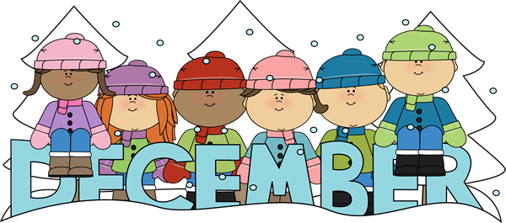

Class Information